**P.RAJYALAKSHMI(192011200)**

**USING RAPTOR – CALCULATE FIBONACCI SERIES**

**FLOWCHART**

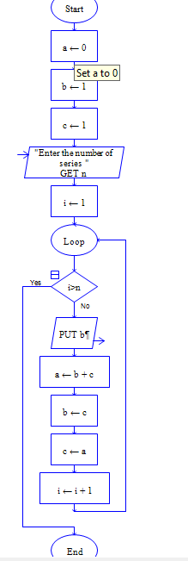

**OUTPUT**

INPUT IS 9

